# Aws Cloud front & Route 53

**Objective:**

The objective of this assignment is to design and implement a complete end-to-end cloud infrastructure solution on AWS by configuring cross-region VPC peering, deploying a static website using Amazon S3, and enabling global content delivery with Amazon CloudFront. This includes purchasing and configuring a custom domain from GoDaddy, securing the website using an SSL certificate, and integrating the domain with AWS Route 53 for DNS management. The task further aims to validate successful deployment by updating website content and ensuring accessibility through the custom domain. The final deliverable will demonstrate the ability to deploy a publicly accessible, secure, and scalable web application using AWS services and third-party DNS management.

1. Configure VPC peering in cross regions.

* Created two vpc’s one in united states North Virginia. Other in EU Stockholm.

* Created two subnets (public, private) in both regions

* Created two route tables (public, private) in both regions
* Added respective subnets to their route tables in subnet association option.

* Created one internet gateway in both regions. First igw to vpc .Attached their ID’s in public route tables.

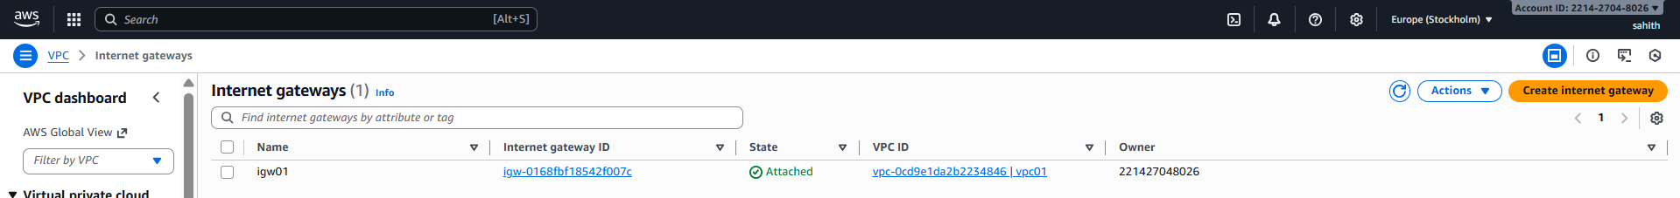

* Created a vpc peering connection. Sent a request from North Virginia region to Europe Stockholm

* Accepted the request sent from north Virginia.

* Validation: as we can see below screenshot. It is connecting with private Ip of other ec2

1. Purchase one domain from GoDaddy.

* Go to GoDaddy.com website > create an account > search for domain name > add to cart > click on buy now follow the steps.

* As we can see below, I have purchased domain name **shoppiex. store**

* Validation: Website launched.

1. Deploy static website in S3.

* Created an s3 bucket with domain name

* Uploaded index.html and error.html from local machine. And made them public acls

* Create a static website hosting > gave domain name > gave both file names > click on create.

* Here we can see that it has been static website has been created

* Validation: we can check it in browser.

4.Create a CDN and attach one SSL certificate.

* Create a Route 53 hosted zone and map the domain with the CDN.
* Update the index.html in the S3 bucket and ensure the updated file is accessible using the domain name.
* Aws console > Route 53 > create hosted zone > in domain name gave shoppiex.store > remaining everything keep them default and click on create hosted zone.

* Hosted zone has been created successfully

* From the created hosted zone copy the value/route traffic, which is marked below.

* Redirect to GoDaddy website where we purchased the domain > select profile > DNS > domain name > nameservers.
* In name servers first remove old names add route traffic which we copied in before step by removing (.) at the end and save them.

* Go to Aws certificate manager > Create a certificate > request > select request a public certificate in certificate type > provide domain name here and keep remaining everything default > click on create certificate.

* As we can see below certificate has been created successfully.

* Go to cloud front > Distributions > give distribution name > select next

* keep everything default in this page, move to next page.

* keep everything default in this page, click on create distribution.

* as we can see below distribution has been created successfully.

* once distribution has been created, move to create origin > gave path name > selected public > click on create orgin

* as we can origin has been created successfully.

* Go to invalidation > create invalidation with /index.html

* Go to invalidation > create invalidation with /*

* Navigate to s3 bucket and update and make them public from actions option.

* Website is working perfectly.

